Synopsis

(PCA20P02L: Mini Project Work)

On

“Bo**A**t-lifestyle.com”

By:

Student Name: Md Enamullah

Reg. No.: RA2332241030042

Branch and Year: MCA- IIIrd Sem/ IInd Year

Under the Guidance of :

Faculty name: Dr. Akshita Chaudhary, Assistant Professor

Project Coordinator: Dr. Rupak Sharma, Associate Professor



Department of Computer Applications

SRM INSTITUTE OF SCIENCE & TECHNOLOGY,

NCR CAMPUS, MODINAGAR

GHAZIABAD, (U.P.)

**Table Of Contents**

|  |  |  |
| --- | --- | --- |
| **Sl.No.** | **Topics** | **Page No.** |

|  |  |  |
| --- | --- | --- |
| **1.** | **Abstract**  1.1 What is problem facing now a days with Your  topic and technology.  1.2 What is improvement you are thinking. | 01  02 |
| **2.** | **Introduction**  2.1 Topic  2.2 History of Online shopping  2.3 Concern technology in market  2.4 Difference with previous Technology used  2.5 Application area | 03  03  03  04  04 |
| **3.** | **Project Plan Module**  3.1 Admin Module  3.2 Customer Module  3.3 Mechanism Module | 05 |
| **4.** | **Project Plan Definition**  4.1 All Use Sub Module Definition  4.2 Features Extraction  4.3 Classification | 05 |
| **5.** | **SRS Report**  5.1 Introduction of SRS  5.1.1 Scenario  5.1.2 Purpose  5.1.3 Scope  5.1.4 Purpose Solution Overview  5.2 Requirements and Analysis  5.2.1 Functional Requirement  5.2.2 Nonfunctional Requirement  5.2.3 Software Requirement  5.2.4 Hardware Requirement | 09  11 |
| **6.** | **Project Design**  6.1 Use Case Diagram  6.2 Activity Chart  6.3 DFD 1-Level  6.4 ER-Diagram | 14  15  16  17 |
| **7.** | **Implementation**  7.1 Code  7.1.1 HTML Code  7.1.2 CSS Code  7.1.3 JavaScript Code  7.2 Result Screenshot | 18  34  58  60 |
| **8.** | **Future Work** | 63 |

|  |  |  |
| --- | --- | --- |
| **9.** | **References** | 64 |

**ABSTRACT**

This system provides an easy solution for customers to buy product without going to the shop and also to shop owner to sale the electronics product in this site.

This proposed system can be used by any naive users and it does not require any educational level, experience or technical expertise in computer field but it will be of good use if user has the good knowledge of how to operate a computer.

This project is a web based shopping and booking system for an existing shop. The project objective is to deliver the online shopping application into android platform. This project is an attempt to provide the advantages of online shopping to customers of a real shop. It helps buying the electronic products in the shop anywhere through internet by using an android device. Thus the customer will get the service of online shopping and home delivery from his favorite shop. This system can be implemented to any shop in the locality or to multinational branded shops having retail outlet chains. If shops are providing an online portal where their customers can enjoy easy shopping from anywhere, the shops won't be losing any more customers to the trending online shops such as Amazon or ebady. Since the application is available in the Smartphone it is easily accessible and always available.

**What is problem facing now a days with topic & technology:**

**Product Quality issue-** The biggest problem while buying things online is that you have no guarantee of a products quality. Reviews are not always reliable and all the research cant assure you of a products quality; fraudulent seller who intentionally mislead customers to increase sales are the prime reason for faulty/subpar products being sold online.

**Delivery And Logistics :-** One predicament that constantly turns up while shopping online is when the order will be delivered. While boat-lifestyle.com site have order tracking systems for their customers, they aren't always accurate. Delivery personnel often turn up at our homes when we're at work or out somewhere as there's no way to fix a particular time slot for the delivery to take place. This same issue exists while returning products.

**Digital Payment Failures;-** Whether a customer is paying by credit/debit card, net banking, or one of the several digital wallets that exist today, the failure of digital payments always looms overhead while making online transactions. A faltering internet connection or a technical glitch often results in the payable amount being debited from a customer's account without being credited to the selling party. And retrieving this amount is anything but a quick process; one has to inform the site and then wait around 7-10 days before the amount is refunded to their bank accounts. But this situation is steadily improving as the sector is focusing more on cashless transactions and customers are getting more informed about making payments online.

**What improvement you are thinking for my projects**

**Make your website mobile friendly-** Nowadays, most people aren't viewing your website on a computer or laptop. They're much more likely to be perusing your goods on a phone or laptop. That's why it's crucial to have a mobile friendly version of your site. This makes it much easier to browse, and shows customers that you care about their experience with you.

**Make your site easy to navigate:**- Nothing's worse than a site where the customer can't see where to go. Map your site out so they can see exactly what you sell, and where they should go to get it. It saves them time and hassle when they come to buy.

**Use good photos:-** Show your customer what the product looks like from every angle. It helps them make the most informed choice before they hit 'add to cart' .Also, make sure the photos are of high a quality as possible. They need to be able to see everything there is to see. Allowing customers to add photos to reviews is another way to help them get a really good look, too.

**INTRODUCTION**

Online Electronics product Booking and gadgets Shopping System application enables vendors to set up online electronic gadget and shops, customer to browse through the electronics and gadget shop, and a system administrator to approve and reject requests for new electronic and shops and maintain lists of electronics and wearable shops. Also the developer is designing an online gadget booking and wearable shopping System site to manage the list of electronic items and also help customers to purchase and booking them online without visiting the electronic shop physically. The online electronic product booking sopping system will use the internet as the sole method for selling goods to its consumer.

**History of Online shopping:-**

The first secure retail transaction over the Web was either by Net Market or Internet Shopping Network in 1994. Immediately after, Amazon.com launched its online shopping site in 1995 and eBay was also introduced in 1995. Alibaba's sites Taobao and Tmall were launched in 2003 and 2008, respectively.

Online shopping started early in 1995 by the introduction of internet in India. Online shopping became popular during the Internet boom in 1999-2000 with the well know auction site know as bazee.com.

My project is similar to online shopping. Online Gadget Booking And Buying wearable item. Means my project's history will also be related in the Booking and shopping applications.

**Concern technology in market:-**

Wearable product just like online shopping is a form of electronic commerce which allows Consumers to directly buy goods or services from a seller over the Internet using a web browser or a mobile app. Consumers find a product of interest by visiting the website of the retailer directly or by searching among alternative vendors using a shopping and mechanics booking search engine, which mechanics booking availability and pricing different e-retailers. customers can shop online using a range of different computers displays the same product's pricing at different e-retailers.

**Difference with previous technology used with new one you are using:**

The earlier technology was very old means that the earlier technology was written only S which was not that good, reliable, flexible ,security And now the technology is very flexible, reliable and very strong security provided. And whatever technology I have done which is HTML, CSS, JavaScript and also using stripe database and payment gateway etc.

* **Enhanced User Experience**

Previous Technology**:** Basic interfaces with limited interactivity.

New Technology**:** Modern systems use AI and machine learning to provide personalized shopping experiences, recommending products based on user preferences and past behavior.

* **Sustainability and Smart Materials**Previous Technology: Conventional materials with limited focus on sustainability.

New Technology: Increased use of sustainable and smart materials that are eco-friendly and offer additional functionalities, such as temperature regulation and biometric monitoring.

* **Real-Time Analytics**Previous Technology: Delayed data processing and analysis.

New Technology: Real-time analytics enable immediate feedback and adjustments, improving inventory management and customer satisfaction.

**Application Area:**

www.boat-lifestyle.com

**PROJECT PLAN MODULE**

The system after careful analysis has been identified to be presented with the following modules and roles. The modules involved

**1.Admin**

**2.Customer**

**3.Machanism**

**PROJECT MODULE DEFINITION**

**1.Admin:**

The administrator is the super user of this application. Only admin have access into this admin page. Admin may be the owner of the shop. The administrator has all the information about all the users and about all products. This module is divided into different sub-modules.

1.1 Manage Products

1.2 Manage Users

1.3 Manage Orders

**Manage Products**

Add Products:-

The shopping cart project contains different kind of products. The products can be classified into different categories by name. Admin can add new products into the existing system with all its details including an image.

Delete Products :-

Administrator can delete the products based on the stock of that particular product.

Search products:- Admin will have a list view of all the existing products. He can also search for a particular product by name.

**Manage Users**

View Customers:-

The admin will have a list view of all the customers registered in the system. Admin can view all the details of each customer in the list except password.

Add Customer:-

Admin has privileges to add a user directly by providing the details.

Delete & Block Users :-

has a right to delete or block a customers. The default status of a new user registered is set as blocked. The admin must accept the new customer by

**Manage Order/Booking**

View Order :-

Administrator can view the Orders which is generated by the users. He can verify the details of the purchase.

Delete order:-

Admin can delete order from the orders list when the product is taken for delivery

**USER(CUSTOMERS):**

**View Products**

User can view the list of products based on their names after successful login. A detailed description of a particular product with product name, products details, product image, price can be viewed by users.

**Search Product**

Users can search for a particular product in the list by name.

**Add to cart Product**

The user can add the desired product into his cart by clicking add to cart option on the product. He can view his cart by clicking on by cart can be viewed in the cart. User can remove an item from the cart by clicking remove.

**Checkout Cart**

After confirming the items in the cart the user can submit the cart by providing a delivery address. On successful submitting the cart will become empty.

**History**

In the history the user will have a view of pending orders.

**MACHANISM:**

**User Interface (UI/UX)**

* Search and Navigation: Users can search for products using keywords, categories, and filters (price range, brand, etc.).
* Product Display: Products are shown with images, descriptions, prices, and customer reviews.
* Shopping Cart: Allows users to add items they intend to purchase, adjust quantities, and see the total cost before checkout.
* User Account System: Enables users to create profiles, save preferences, and track order history.

**Product Catalog Management**

* Inventory Database: Stores information about available products, including stock levels, prices, and descriptions.
* Search Engine Optimization (SEO): Ensures that product listings are easily found by search engines, improving visibility.
* Product Recommendations: Suggests additional products based on user preferences, browsing history, and past purchases using algorithms (collaborative filtering, content-based recommendations).

**Order Management System (OMS)**

* Order Processing: Once a user places an order, it triggers the order processing system, which verifies stock availability and reserves the item.
* Order Tracking: After the order is confirmed, users can track the shipment and delivery status.
* Shipping and Logistics: The system integrates with third-party shipping companies for delivery updates.

**Payment Gateway**

After the checkouts make your payments through UPI , net banking and cards with secure network.

* Payment Processing: Securely handles payments by connecting the shopping platform with financial institutions (banks, credit cards, payment services like PayPal or Stripe).
* Security (SSL, PCI Compliance): Encrypts sensitive data such as credit card information during transactions to prevent fraud and data breaches.
* Fraud Detection: Uses algorithms and machine learning to detect suspicious activity and reduce the risk of fraudulent transactions.

**Customer Service Mechanism**

* Help Desk: Provides assistance for user queries, issues with orders, or product returns. Automated chatbots or human customer service agents may be used.
* Returns and Refunds Management: Facilitates the process for users to return items and receive refunds.

**Content Management System (CMS)**

* Product Information Management (PIM): Ensures accurate, detailed, and up-to-date product listings.
* Blog/Content Updates: Allows the store to publish news, updates, or promotional content to engage customers.

**SOFTWARE REQUIREMENT SPECIFICATION (SRS)**

INTRODUCTION OF SRS

**Scenario:**

Software Requirement Specification (SRS) Format as name suggests, is complete specification and description of requirements of software that needs to be fulfilled for successful development of software system. These requirements can be functional as well as non-functional depending upon type of requirement. Nowadays many individuals are showing their interests to adopt various technical fields. They should identify their interests, to determine whether they are in the right path to reach their targets and to strengthen the weak areas to be successful. To know all these there should be a pre valuation of all the skills that an individual knows. This model is proposed the Online Booking and shopping System for electronics and wearable products booking web application is intended to provide complete solutions for vendors as well as customers through a single get way using the internet.

**Purpose:**

This document is meant to delineate the features of OWSS, so as to serve as a guide to the developers on one hand and a software validation document for the prospective client on the other.

The Online Wearable Shopping System (OWSS) for electronic and wearable product booking web application is intended to provide complete solutions for vendors as well as customers through a single get way using the internet. It will enable venders to setup online mechanism and shops, customer to browse through the shop and booking, purchase them online without having to visit the electronics shop physically. The administration module will enable a system administrator to approve and reject requests for new electronic shops and maintain various lists of electronic shop category.

**Scope:**

* This system allows the customer's to maintain their cart for add or remove the product over the internet
* This system allows the customer's to Physically maintain their current address for solving the problem over the internet
* This system allows the customer's to automatically maintain their current address for solving the problem over the internet
* This system allows the customer's to return the product when

Product is not uses and recover the product price

**Definitions:**

OWSS – Online Wearable Product Booking System.

SRS - Software Requirement Specification

GUI - Graphical User Interface

Stack holder - The person who will participate in system

Ex. Customer, Administrator, Visitor etc.

**Overview:**

This system provides an easy solution for customers to booking and buy the electronic and wearable product without going to the shop and also to shop owner to sale the wearable product.

This proposed system can be used by any naïve users and it does not require any educational level, experience or technical expertise in computer field but it will be of good use if user has the good knowledge of how to operate a computer.

**Overall Description:**

Online Wearable Booking System(OWBS) application enables vendors to set up online electronics product shops, customer to browse through the electronic wearable shop, and a system administrator to approve and reject requests for new wearable shops and maintain lists of product items. Also the developer is designing an online order booking and wearable product shopping System site.

**Product Functions:**

OWSS should support this use case.

**User Characteristics:**

User should be familiar with the terms like login, register, booking mechanism, order system etc.

**Principle Actors:**

Principle Actors are Customer and Administrator.

**General Constraints:**

A full internet connection is required for Online shopping system(OSS).

**Assumptions and Dependencies:**

Working of OSS need Internet Connection.

**Functional Requirements:**

This section provides requirement overview of the system. Various functional modules that can be implemented by the system will be-

**View Products**

User can view the list of products based on their names after successful login. A detailed description of a particular product with product name, products details, product image, price can be viewed by users.

**Search Product**

Users can search for a particular product in the list by name.

**Add to cart Product**

The user can add the desired product into his cart by clicking add to cart option on the product. He can view his cart by clicking on by cart can be viewed in the cart. User can remove an item from the cart by clicking remove.

**Changes to Cart**

Changes to cart means the customer after login or registration can make booking, order or cancel order of the product from the shopping cart.

**Payment**

In this system we are dealing the mode of payment by Cash.We will extend this to credit card, debit card and UPI etc in the future.

**Non-Functional Requirements:**

Following Non-Functional Requirements will be there in the insurance to the internet:

* Secure access to consumer's confidential data.
* 24X7 availability.
* Security Reliability
* Maintainability
* Portability
* Extensibility
* Reusability Compatibility
* Resource Utilization

**Interface Requirement:**

Various interfaces for the product could be-

(1). Showing Page

(2). Scrolling Page

(3). There will be a screen displaying information about product, mechanic that the shop having.

(4). If the customers select the buy, book button then another screen of shopping, booking cart will be opened.

(5). After ordering for the product, the system will sent one copy of the bill to the customer's Email address

**Software Interface**

**Operating System:**

Windows 7, windows 8, windows 10, windows 11 Ultimate which supports networking.

Software development toolkit

**Hardware Interface**

Hardware requirements for insurance on internet will be same for both parties which are as follows:

* RAM: 2 GB
* Processor: Dual Core
* Software Interface:
* Hard Disk: 320 GB
* NIC: For each party

**Communication Interfaces:**

The two should be connected by LAN or WAN for the communication purpose.

**RECEIVER**

**SENDER**

**Communication**

**PROJECT DESIGN**

**Use-Case Diagram (Online Wearable Shopping System):**

A use case diagram is used to represent the dynamic behavior of a system. It encapsulates the system’s functionality by incorporating use cases, actors, and their relationships. It models the tasks, services, and functions required by a system/subsystem of an application. It depicts the high-level functionality of a system and also tells how the user handles a system.

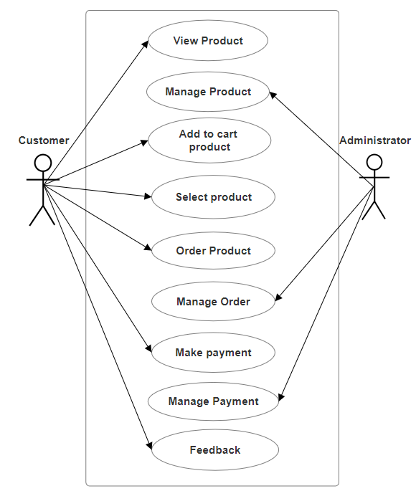

**Activity Chart (Online Wearable Shopping System):**

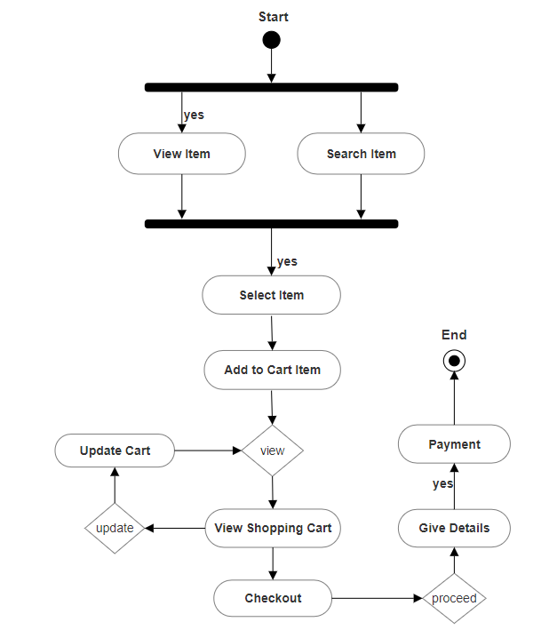

**1-Level DFD (Online Wearable Shopping System):**

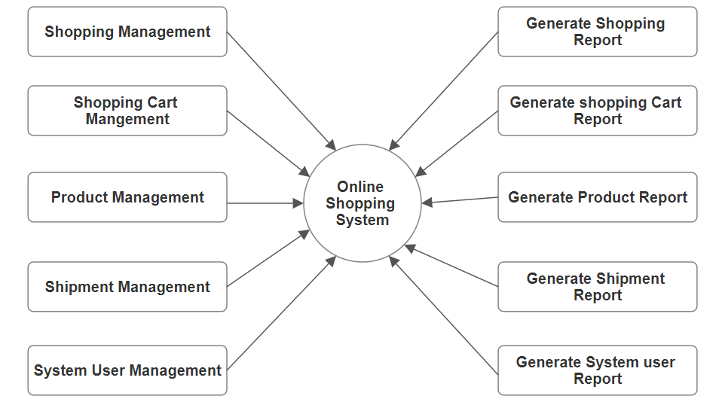

**ER-Diagram (Online Wearable Shopping System):**

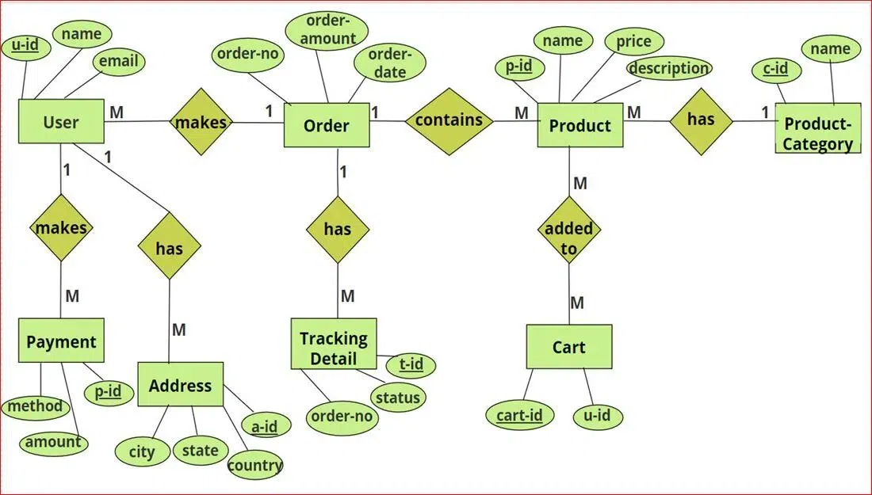

**IMPLEMENTATION**

**HTML CODE:**

<--Home.html-->

**<!DOCTYPE html>**

**<html lang="en">**

**<head>**

**<meta charset="UTF-8">**

**<meta name="viewport" content="width=device-width, initial-scale=1.0">**

**<title>ENAMUL^STORES</title>**

**<link rel="stylesheet" href="/home.css">**

**<link rel="stylesheet" href="https://maxcdn.bootstrapcdn.com/font-awesome/4.4.0/css/font-awesome.min.css">**

**</head>**

**<body>**

**<!-- Home -->**

**<div class="home" id="home">**

**<header class="main-header">**

**<div class="header-content">**

**<ul class="left">**

**<li><a href="#home">Home</a></li>**

**<li><a href="#footer">About</a></li>**

**<li><a href="#category">Categories</a></li>**

**</ul>**

**<div class="center">**

**ENAMUL^STORE**

**</div>**

**<div class="right">**

**<i class="fa fa-search" style="font-size:20px;color:aliceblue"></i>**

**<i class="fa fa-heart" style="font-size: 20px;color:aliceblue"></i>**

**<a href="shoppingCart.html"><i class="fa fa-shopping-cart" style="font-size: 20px;color:aliceblue"></i><sup>2</sup></a>**

**</div>**

**</div>**

**</header>**

**<!-- home item -->**

**<div class="home-item">**

**<div class="sale">**

**<h1>SALES</h1>**

**<p>Explore and buy top quality electronic gadgets with lowest price and high performance.</p>**

**</div>**

**<div class="img">**

**<img src="images/banner-img.png" style="width:100%" alt="">**

**</div>**

**</div>**

**</div>**

**<!-- Categories Item -->**

**<div class="shop-by-category" id="category">**

**<div class="cat-text">**

**Top Categories**

**</div>**

**<div class="categories">**

**<div class="category">**

**<img src=images/cat-1.jpg alt="" />**

**</div>**

**<div class="category">**

**<img src=images/cat-2.jpg alt="" />**

**</div>**

**<div class="category">**

**<img src=images/cat-3.jpg alt="" />**

**</div>**

**<div class="category">**

**<img src=images/cat-4.jpg alt="" />**

**</div>**

**</div>**

**</div>**

**<!-- Product Item -->**

**<div class="products-container">**

**<div class="sec-heading">Popular Products</div>**

**<div class="products">**

**<div class="product-card">**

**<div class="thumbnail">**

**<img src="images/earbuds-prod-1.webp" alt="">**

**</div>**

**<div class="prod-details">**

**<span class="name">TRebel Airdopes 141 | 8mm drivers, Upto 42 Hours Total Playback, ENxTM Technology, ASAPTM Charge</span>**

**<span class="price">&#8377;1,499</span>**

**</div>**

**</div>**

**<div class="product-card">**

**<div class="thumbnail">**

**<a href="singleItem.html"><img src="images/headphone-prod-6.webp" alt=""></a>**

**</div>**

**<div class="prod-details">**

**<span class="name">Rockerz 450 Superman DC Edition - Wireless Bluetooth Headphone</span>**

**<span class="price">&#8377;1,999</span>**

**</div>**

**</div>**

**<div class="product-card">**

**<div class="thumbnail">**

**<img src="images/speaker-prod-1.webp" alt="">**

**</div>**

**<div class="prod-details">**

**<span class="name">Stone 1500F | 14W boAt Signature Sound with Passive Bass Radiator</span>**

**<span class="price">&#8377;3,999</span>**

**</div>**

**</div>**

**<div class="product-card">**

**<div class="thumbnail">**

**<img src="images/watch-prod-1.webp" alt="">**

**</div>**

**<div class="prod-details">**

**<span class="name">boAt Wave Neo | 1.69" HD Display, Upto 7 Days Battery Life, IP68 Sweat</span>**

**<span class="price">&#8377;1,799</span>**

**</div>**

**</div>**

**<div class="product-card">**

**<div class="thumbnail">**

**<img src="images/speaker-prod-2.webp" alt="">**

**</div>**

**<div class="prod-details">**

**<span class="name">Stone 1000v2</span>**

**<span class="price">&#8377;2,999</span>**

**</div>**

**</div>**

**<div class="product-card">**

**<div class="thumbnail">**

**<img src="images/watch-prod-2.webp" alt="">**

**</div>**

**<div class="prod-details">**

**<span class="name">boAt Iris | Round Dial Smart Watch with 1.39" AMOLED Display, Multiple Watch Faces</span>**

**<span class="price">&#8377;4,499</span>**

**</div>**

**</div>**

**<div class="product-card">**

**<div class="thumbnail">**

**<img src="images/earbuds-prod-2.webp" alt="">**

**</div>**

**<div class="prod-details">**

**<span class="name">Airdopes 131 DC Edition with 13 mm Drivers, Type-C Carry Case, 12 hours Nonstop Music</span>**

**<span class="price">&#8377;1,399</span>**

**</div>**

**</div>**

**<div class="product-card">**

**<div class="thumbnail">**

**<img src="images/headphone-prod-2.webp" alt="">**

**</div>**

**<div class="prod-details">**

**<span class="name">Rockerz 550 Over Ear Bluetooth Headphone</span>**

**<span class="price">&#8377;1,799</span>**

**</div>**

**</div>**

**<div class="product-card">**

**<div class="thumbnail">**

**<img src="images/earbuds-prod-3.webp" alt="">**

**</div>**

**<div class="prod-details">**

**<span class="name">boAt Airdopes 141 Pro | 12mm Drivers, Upto 45 Hours Playback, Quad Mics with ENx™️ Technology</span>**

**<span class="price">&#8377;1,499</span>**

**</div>**

**</div>**

**<div class="product-card">**

**<div class="thumbnail">**

**<img src="images/headphone-prod-3.webp" alt="">**

**</div>**

**<div class="prod-details">**

**<span class="name">boAt Rockerz 518 Wireless Headphone</span>**

**<span class="price">&#8377;1,599</span>**

**</div>**

**</div>**

**<div class="product-card">**

**<div class="thumbnail">**

**<img src="images/speaker-prod-3.webp" alt="">**

**</div>**

**<div class="prod-details">**

**<span class="name">boAt Stone 500 - Portable Bluetooth Speaker</span>**

**<span class="price">&#8377;1,999</span>**

**</div>**

**</div>**

**<div class="product-card">**

**<div class="thumbnail">**

**<img src="images/watch-prod-3.webp" alt="">**

**</div>**

**<div class="prod-details">**

**<span class="name">boAt Vertex | Smartwatch with Fitness Trackers, 1.69" HD Display, Sleep Tracking, 100+ Watch Faces</span>**

**<span class="price">&#8377;2,299</span>**

**</div>**

**</div>**

**<div class="product-card">**

**<div class="thumbnail">**

**<img src="images/speaker-prod-4.webp" alt="">**

**</div>**

**<div class="prod-details">**

**<span class="name">Party Pal 60</span>**

**<span class="price">&#8377;4,999</span>**

**</div>**

**</div>**

**<div class="product-card">**

**<div class="thumbnail">**

**<img src="images/headphone-prod-1.webp" alt="">**

**</div>**

**<div class="prod-details">**

**<span class="name">boAt Rockerz 450 DC edition | Wireless Headphone with 40mm Dynamic Driver</span>**

**<span class="price">&#8377;1,999</span>**

**</div>**

**</div>**

**<div class="product-card">**

**<div class="thumbnail">**

**<img src="images/earbuds-prod-4.webp" alt="">**

**</div>**

**<div class="prod-details">**

**<span class="name">boAt Airdopes 441 | Wireless Earbuds with 6mm Driver For Immersive Sound</span>**

**<span class="price">&#8377;2,499</span>**

**</div>**

**</div>**

**<div class="product-card">**

**<div class="thumbnail">**

**<img src="images/headphone-prod-4.webp" alt="">**

**</div>**

**<div class="prod-details">**

**<span class="name">Rockerz 400</span>**

**<span class="price">&#8377;1,299</span>**

**</div>**

**</div>**

**<div class="product-card">**

**<div class="thumbnail">**

**<img src="images/headphone-prod-5.webp" alt="">**

**</div>**

**<div class="prod-details">**

**<span class="name">Trebel Rockerz 550 Wireless Bluetooth Headphones</span>**

**<span class="price">&#8377;1,999</span>**

**</div>**

**</div>**

**<div class="product-card">**

**<div class="thumbnail">**

**<img src="images/watch-prod-1.webp" alt="">**

**</div>**

**<div class="prod-details">**

**<span class="name">boAt Wave Neo | 1.69" HD Display, Upto 7 Days Battery Life, IP68 Sweat</span>**

**<span class="price">&#8377;1,799</span>**

**</div>**

**</div>**

**<div class="product-card">**

**<div class="thumbnail">**

**<img src="images/speaker-prod-5.webp" alt="">**

**</div>**

**<div class="prod-details">**

**<span class="name">boAt Party Pal 50 - Bluetooth Speaker</span>**

**<span class="price">&#8377;3,799</span>**

**</div>**

**</div>**

**<div class="product-card">**

**<div class="thumbnail">**

**<img src="images/earbuds-prod-5.webp" alt="">**

**</div>**

**<div class="prod-details">**

**<span class="name">boAt TRebel Airdopes 402 | In-Ear Earbuds With 10mm Driver, IPX4 Sweat</span>**

**<span class="price">&#8377;1,999</span>**

**</div>**

**</div>**

**</div>**

**</div>**

**<!-- Footer Item -->**

**<div class="footer" id="footer">**

**<div class="footer-content">**

**<div class="col">**

**<div class="title">About</div>**

**<div class="text">**

**This e-commerce website has created only for college project perpose. In this website various feature add like select product, add product in cart, buy product and many more. Here accept payment feature also available through stripe payment getways.**

**</div>**

**</div>**

**<div class="col">**

**<div class="title">Contact</div>**

**<div class="c-item">**

**<div class="text">**

**SRM, Modinagar, Ghaziabad, NCR Delhi,**

**Uttar Pradesh, 201204**

**</div>**

**</div>**

**<div class="c-item">**

**<div class="text">Phone: 0748 821 4948</div>**

**</div>**

**<div class="c-item">**

**<div class="text">Email: store@js-enamul.com</div>**

**</div>**

**</div>**

**<div class="col">**

**<div class="title">Categories</div>**

**<span class="text">Headphones</span>**

**<span class="text">Smart Watches</span>**

**<span class="text">Bluetooth Speakers</span>**

**<span class="text">Wireless Earbuds</span>**

**<span class="text">Home Theatre</span>**

**<span class="text">Projectors</span>**

**</div>**

**<div class="col">**

**<div class="title">Pages</div>**

**<span class="text">Home</span>**

**<span class="text">About</span>**

**<span class="text">Privacy Policy</span>**

**<span class="text">Returns</span>**

**<span class="text">Terms & Conditions</span>**

**<span class="text">Contact Us</span>**

**</div>**

**</div>**

**<div class="bottom-bar">**

**<div class="bottom-bar-content">**

**<span class="text">**

**ENAMUL^STORE 2024 CREATED BY ENAMUL. PREMIUM E-COMMERCE**

**SOLUTIONS.**

**</span>**

**<img src="images/payments.png" alt="" />**

**</div>**

**</div>**

**</div>**

**</body>**

**</html>**

<--ShoppingCart.html-->

**<!DOCTYPE html>**

**<html>**

**<head>**

**<title>Shopping Cart</title>**

**<meta charset="utf-8">**

**<meta name="viewport" content="width=device-width, initial-scale=1.0">**

**<link href="https://cdn.jsdelivr.net/npm/bootstrap@5.0.2/dist/css/bootstrap.min.css" rel="stylesheet"**

**integrity="sha384-EVSTQN3/azprG1Anm3QDgpJLIm9Nao0Yz1ztcQTwFspd3yD65VohhpuuCOmLASjC" crossorigin="anonymous">**

**<link href="https://cdnjs.cloudflare.com/ajax/libs/font-awesome/5.11.2/css/all.css" rel="stylesheet" />**

**<link href="shoppingCart.css" rel="stylesheet">**

**<link rel="stylesheet" href="https://maxcdn.bootstrapcdn.com/font-awesome/4.4.0/css/font-awesome.min.css">**

**</head>**

**<body>**

**<!-- Header section -->**

**<section class="section">**

**<header class="main-header">**

**<div class="header-content">**

**<ul class="left">**

**<li><a href="Home.html">Home</a></li>**

**<li><a href="#footer">About</a></li>**

**<li><a href="#">Categories</a></li>**

**</ul>**

**<div class="center">**

**SHOPPING CART**

**</div>**

**<div class="right">**

**<i class="fa fa-search" style="font-size:20px;color:aliceblue"></i>**

**<i class="fa fa-heart" style="font-size: 20px;color:aliceblue"></i>**

**</div>**

**</div>**

**</header>**

**<!-- Cart Section -->**

**<div class="container">**

**<div class="cart">**

**<h3>Cart Items</h3>**

**<div class="col-md-12 col-lg-10 mx-auto">**

**<div class="cart-item">**

**<div class="row">**

**<div class="col-md-7 center-item">**

**<img src="images/headphone-prod-6.webp" alt="">**

**<h5>boAt Rockerz 450 DC edition | Wireless Headphone with 40mm Dynamic Driver( &#8377;1,999 )</h5>**

**</div>**

**<div class="col-md-5 center-item">**

**<div class="input-group number-spinner">**

**<button id="phone-minus" class="btn btn-default"><i class="fas fa-minus"></i></button>**

**<input id="phone-number" type="number" min="0" class="form-control text-center" value="1">**

**<button id="phone-plus" class="btn btn-default"><i class="fas fa-plus"></i></button>**

**</div>**

**<h5>&#8377; <span id="phone-total">1,999</span> </h5>**

**<img src="images/remove.png" alt="" class="remove-item">**

**</div>**

**</div>**

**</div>**

**<div class="cart-item">**

**<div class="row">**

**<div class="col-md-7 center-item mx-auto">**

**<img src="images/watch-prod-1.webp" alt="">**

**<h5>boAt Wave Neo | 1.69" HD Display, Upto 7 Days Battery Life, IP68 Sweat( &#8377;1,799 )</h5>**

**</div>**

**<div class="col-md-5 center-item">**

**<div class="input-group number-spinner">**

**<button id="case-minus" class="btn btn-default"><i class="fas fa-minus"></i></button>**

**<input id="case-number" type="number" min="0" class="form-control text-center" value="1">**

**<button id="case-plus" class="btn btn-default"><i class="fas fa-plus"></i></button>**

**</div>**

**<h5>&#8377; <span id="case-total">1,799</span> </h5>**

**<img src="images/remove.png" alt="" class="remove-item">**

**</div>**

**</div>**

**</div>**

**<div class="cart-item">**

**<div class="row g-2">**

**<div class="col-6">**

**<h5>Subtotal: </h5>**

**<h5>Tax:</h5>**

**<h5>Total:</h5>**

**</div>**

**<div class="col-6 status">**

**<h5>&#8377;<span id="sub-total">3,798</span></h5>**

**<h5>&#8377;<span id="tax-amount">379.8</span></h5>**

**<h5>&#8377;<span id="total-price">4,177.8</span></h5>**

**</div>**

**</div>**

**</div>**

**<div class="col-md-12 pt-4 pb-4">**

**<button onclick="location.href='https://buy.stripe.com/test_9AQ4jaeJb39p9Ec4gh'" type="button"**

**class="btn btn-success check-out">Check Out</button>**

**</div>**

**</div>**

**</div>**

**</div>**

**</section>**

**<!-- Footer -->**

**<div class="footer" id="footer">**

**<div class="footer-content">**

**<div class="col">**

**<div class="title">About</div>**

**<div class="text">**

**This e-commerce website has created only for college project perpose. In this website various feature add**

**like select product, add product in cart, buy product and many more. Here accept payment feature also**

**available through stripe payment getways.**

**</div>**

**</div>**

**<div class="col">**

**<div class="title">Contact</div>**

**<div class="c-item">**

**<div class="text">**

**SRM, Modinagar, Ghaziabad, NCR Delhi,**

**Uttar Pradesh, 201204**

**</div>**

**</div>**

**<div class="c-item">**

**<div class="text">Phone: 0748 821 4948</div>**

**</div>**

**<div class="c-item">**

**<div class="text">Email: store@js-enamul.com</div>**

**</div>**

**</div>**

**<div class="col">**

**<div class="title">Categories</div>**

**<span class="text">Headphones</span>**

**<span class="text">Smart Watches</span>**

**<span class="text">Bluetooth Speakers</span>**

**<span class="text">Wireless Earbuds</span>**

**<span class="text">Home Theatre</span>**

**<span class="text">Projectors</span>**

**</div>**

**<div class="col">**

**<div class="title">Pages</div>**

**<span class="text">Home</span>**

**<span class="text">About</span>**

**<span class="text">Privacy Policy</span>**

**<span class="text">Returns</span>**

**<span class="text">Terms & Conditions</span>**

**<span class="text">Contact Us</span>**

**</div>**

**</div>**

**<div class="bottom-bar">**

**<div class="bottom-bar-content">**

**<span class="text">**

**ENAMUL^STORE 2024 CREATED BY ENAMUL. PREMIUM E-COMMERCE**

**SOLUTIONS.**

**</span>**

**<img src="images/payments.png" alt="" />**

**</div>**

**</div>**

**</div>**

**<script src="app.js"></script>**

**</body>**

**</html>**

<--singleItem.html-->

**<!DOCTYPE html>**

**<html lang="en">**

**<head>**

**<meta charset="UTF-8">**

**<meta name="viewport" content="width=device-width, initial-scale=1.0">**

**<title>Single Item</title>**

**<link rel="stylesheet" href="\singleItem.css">**

**<link rel="stylesheet" href="https://maxcdn.bootstrapcdn.com/font-awesome/4.4.0/css/font-awesome.min.css">**

**<link rel="stylesheet" href="https://cdnjs.cloudflare.com/ajax/libs/font-awesome/4.7.0/css/font-awesome.min.css">**

**</head>**

**<body>**

**<!-- Header -->**

**<div class="home" id="home">**

**<header class="main-header">**

**<div class="header-content">**

**<ul class="left">**

**<li><a href="Home.html">Home</a></li>**

**<li><a href="#footer">About</a></li>**

**<li><a href="#category">Categories</a></li>**

**</ul>**

**<div class="center">**

**Single Item**

**</div>**

**<div class="right">**

**<i class="fa fa-search" style="font-size:20px;color:aliceblue"></i>**

**<i class="fa fa-heart" style="font-size: 20px;color:aliceblue"></i>**

**<a href="shoppingCart.html"><i class="fa fa-shopping-cart" style="font-size: 20px;color:aliceblue"></i><sup>2</sup></a>**

**</div>**

**</div>**

**</header>**

**</div>**

**<!-- Single Item -->**

**<div class="single-product-main-content">**

**<div class="layout">**

**<div class="single-product-page">**

**<div class="left1">**

**<img src="/Images/headphone-prod-6.webp" alt="" />**

**</div>**

**<div class="right1">**

**<span class="name">Rockerz 450 Superman DC Edition - Wireless Bluetooth Headphone</span>**

**<span class="price">&#8377;1,999</span>**

**<span class="desc">There is no better justice to your playlist than Rockerz 450 boAt | DC edition. If low battery is your enemy, the 15HRS non-stop playback is here to rightfully combat that. Feel the power rising up in your veins, just like the sun powers the Man of Steel, as you indulge in your playlist with its 40mm dynamic drivers. Be your own hero as you get ready to rule with #DCYOU.</span>**

**<div class="cart-buttons">**

**<div class="quantity-buttons">**

**<span>-</span>**

**<span>5</span>**

**<span>+</span>**

**</div>**

**<button class="add-to-cart-button">**

**<i class="fa fa-shopping-cart" style="font-size: 20px;color:aliceblue"></i>**

**ADD TO CART**

**</button>**

**</div>**

**<div class="info-item">**

**<span class="text-bold">**

**Category:**

**<span>Headphones</span>**

**</span>**

**<span class="text-bold">**

**Share:**

**<span class="social-icons">**

**<a href="#" class="fa fa-facebook"></a>**

**<a href="#" class="fa fa-twitter"></a>**

**<a href="#" class="fa fa-linkedin"></a>**

**<a href="#" class="fa fa-instagram"></a>**

**<a href="#" class="fa fa-pinterest"></a>**

**</span>**

**</span>**

**</div>**

**</div>**

**</div>**

**</div>**

**</div>**

**<!-- Related product -->**

**<div class="products-container">**

**<div class="sec-heading">Related Products</div>**

**<div class="products">**

**<div class="product-card">**

**<div class="thumbnail">**

**<img src="images/headphone-prod-2.webp" alt="">**

**</div>**

**<div class="prod-details">**

**<span class="name">Rockerz 550 Over Ear Bluetooth Headphone</span>**

**<span class="price">&#8377;1,799</span>**

**</div>**

**</div>**

**<div class="product-card">**

**<div class="thumbnail">**

**<img src="images/headphone-prod-3.webp" alt="">**

**</div>**

**<div class="prod-details">**

**<span class="name">boAt Rockerz 518 Wireless Headphone</span>**

**<span class="price">&#8377;1,599</span>**

**</div>**

**</div>**

**<div class="product-card">**

**<div class="thumbnail">**

**<img src="images/headphone-prod-1.webp" alt="">**

**</div>**

**<div class="prod-details">**

**<span class="name">boAt Rockerz 450 DC edition | Wireless Headphone with 40mm Dynamic Driver</span>**

**<span class="price">&#8377;1,999</span>**

**</div>**

**</div>**

**<div class="product-card">**

**<div class="thumbnail">**

**<img src="images/headphone-prod-4.webp" alt="">**

**</div>**

**<div class="prod-details">**

**<span class="name">Rockerz 400</span>**

**<span class="price">&#8377;1,299</span>**

**</div>**

**</div>**

**</div>**

**</div>**

**<!-- Footer Item -->**

**<div class="footer" id="footer">**

**<div class="footer-content">**

**<div class="col">**

**<div class="title">About</div>**

**<div class="text">**

**This e-commerce website has created only for college project perpose. In this website various feature add like select product, add product in cart, buy product and many more. Here accept payment feature also available through stripe payment getways.**

**</div>**

**</div>**

**<div class="col">**

**<div class="title">Contact</div>**

**<div class="c-item">**

**<div class="text">**

**SRM, Modinagar, Ghaziabad, NCR Delhi,**

**Uttar Pradesh, 201204**

**</div>**

**</div>**

**<div class="c-item">**

**<div class="text">Phone: 0748 821 4948</div>**

**</div>**

**<div class="c-item">**

**<div class="text">Email: store@js-enamul.com</div>**

**</div>**

**</div>**

**<div class="col">**

**<div class="title">Categories</div>**

**<span class="text">Headphones</span>**

**<span class="text">Smart Watches</span>**

**<span class="text">Bluetooth Speakers</span>**

**<span class="text">Wireless Earbuds</span>**

**<span class="text">Home Theatre</span>**

**<span class="text">Projectors</span>**

**</div>**

**<div class="col">**

**<div class="title">Pages</div>**

**<span class="text">Home</span>**

**<span class="text">About</span>**

**<span class="text">Privacy Policy</span>**

**<span class="text">Returns</span>**

**<span class="text">Terms & Conditions</span>**

**<span class="text">Contact Us</span>**

**</div>**

**</div>**

**<div class="bottom-bar">**

**<div class="bottom-bar-content">**

**<span class="text">**

**ENAMUL^STORE 2024 CREATED BY ENAMUL. PREMIUM E-COMMERCE**

**SOLUTIONS.**

**</span>**

**<img src="images/payments.png" alt="" />**

**</div>**

**</div>**

**</div>**

**</body>**

**</html>**

**CSS CODE:**

<--home.css-->

**/*  import google fonts */**

**@import url('https://fonts.googleapis.com/css2?family=Poppins:wght@400;500;600;700&family=Ubuntu:wght@400;500;700&display=swap');**

**\*{**

**margin: 0;**

**padding: 0;**

**box-sizing: border-box;**

**text-decoration: none;**

**font-family: 'Ubuntu', sans-serif;**

**}**

**html{**

**scroll-behavior: smooth;**

**}**

**body {**

**width: 100%;**

**height: auto;**

**font-family: 'Ubuntu', sans-serif;**

**}**

**/* Home section */**

**.home {**

**background: #8d2de2f1;**

**width: 100%;**

**}**

**/* Header section start */**

**.main-header {**

**width: 100%;**

**height: 70px;**

**align-content: center;**

**z-index: 99;**

**background-color: #212121;**

**color: white;**

**border-bottom: 1px solid;**

**border-color: rgba(0, 0, 0, 0.1);**

**position: fixed;**

**}**

**.header-content {**

**display: flex;**

**justify-content: space-between;**

**align-items: center;**

**height: 50px;**

**max-width: 1200px;**

**margin: 0 auto;**

**}**

**.left {**

**list-style-type: none;**

**display: flex;**

**gap: 25px;**

**li a{**

**color: aliceblue;**

**font-size: 18px;**

**font-weight: 600;**

**cursor: pointer;**

**&:hover {**

**opacity: 0.6;**

**}**

**}**

**}**

**.center {**

**font-size: 28px;**

**font-weight: 700;**

**cursor: pointer;**

**&:hover {**

**color: #b85cfefb;**

**transition: 1.5s;**

**}**

**}**

**@media (max-width: 668px) {**

**.center {**

**font-size: 22px;**

**}**

**}**

**@media (max-width: 610px) {**

**.center {**

**font-size: 18px;**

**}**

**}**

**@media (max-width: 577px) {**

**.center {**

**display: none;**

**}**

**}**

**.right {**

**display: flex;**

**align-items: center;**

**gap: 20px;**

**font-size: 18px;**

**}**

**i {**

**min-width: 20px;**

**text-align: center;**

**padding: 2.5px;**

**cursor: pointer;**

**&:hover {**

**opacity: 0.6;**

**}**

**}**

**.right a sup {**

**background-color: red;**

**color: aliceblue;**

**font-size: 13px;**

**margin-left: -4px;**

**padding-left: 4px;**

**padding-right: 4px;**

**border-radius: 100%;**

**}**

**.right a:hover{**

**opacity: 0.6;**

**}**

**/* Home Item */**

**.home-item{**

**display: flex;**

**width: 100%;**

**}**

**.sale{**

**margin-top: 250px;**

**margin-left: 180px;**

**}**

**@media (max-width: 1050px) {**

**.sale {**

**margin: 150px 0px 0px 100px;**

**}**

**}**

**@media (max-width: 760px) {**

**.sale {**

**margin: 140px 0px 0px 80px;**

**}**

**}**

**@media (max-width: 726px) {**

**.sale {**

**margin: 170px 0px 0px 80px;**

**}**

**}**

**@media (max-width: 500px) {**

**.sale {**

**margin: 150px 0px 0px 40px;**

**}**

**}**

**@media (max-width: 400px) {**

**.sale {**

**margin: 140px 0px 0px 30px;**

**}**

**}**

**.sale h1{**

**color: aliceblue;**

**font-size: 130px;**

**padding: 0px 30px;**

**}**

**@media (max-width: 1050px) {**

**.sale h1{**

**font-size: 100px;**

**}**

**}**

**@media (max-width: 760px) {**

**.sale h1{**

**font-size: 70px;**

**}**

**}**

**@media (max-width: 580px) {**

**.sale h1{**

**font-size: 50px;**

**}**

**}**

**@media (max-width: 500px) {**

**.sale h1{**

**font-size: 50px;**

**}**

**}**

**@media (max-width: 400px) {**

**.sale h1{**

**font-size: 45px;**

**}**

**}**

**.sale p{**

**color: aliceblue;**

**width: 430px;**

**text-align: left;**

**padding-left: 37px;**

**}**

**@media (max-width: 1050px) {**

**.sale p{**

**width: 370px;**

**}**

**}**

**@media (max-width: 760px) {**

**.sale p{**

**width: 280px;**

**}**

**}**

**@media (max-width: 580px) {**

**.sale p{**

**width: 200px;**

**}**

**}**

**@media (max-width: 500px) {**

**.sale p{**

**display: none;**

**}**

**}**

**.img{**

**margin-bottom: 50px;**

**}**

**.img img{**

**float: right;**

**max-width: 75%;**

**max-height: auto;**

**margin-top: 80px;**

**margin-right: 40px;**

**}**

**/* Category Section */**

**.shop-by-category {**

**margin: 0px 0;**

**border-top: #d6d4d4d0 20px solid;**

**.cat-text {**

**margin: 0px;**

**border-bottom: #696969 1px solid;**

**margin: 30px 0px 20px 5px;**

**font-size: 22px;**

**font-weight: 500;**

**text-transform: uppercase;**

**&:after {**

**content: "";**

**display: block;**

**margin-top: 5px;**

**width: 50px;**

**height: 3px;**

**background-color: #8e2de2;**

**}**

**}**

**.categories {**

**margin-top: 10px;**

**display: flex;**

**flex-flow: wrap;**

**gap: 10px;**

**.category {**

**background-color: black;**

**width: calc(25% - 7.5px);**

**cursor: pointer;**

**overflow: hidden;**

**img {**

**width: 100%;**

**display: block;**

**transition: all ease 0.3s;**

**}**

**&:hover {**

**img {**

**transform: scale(1.2);**

**}**

**}**

**}**

**}**

**}**

**/* Product Section */**

**.products-container {**

**margin: 50px 0;**

**.sec-heading {**

**border-bottom: #696969 1px solid;**

**margin-bottom: 20px;**

**margin-left: 5px;**

**font-size: 22px;**

**font-weight: 500;**

**text-transform: uppercase;**

**&:after {**

**content: "";**

**display: block;**

**margin-top: 5px;**

**width: 50px;**

**height: 3px;**

**background-color: #8e2de2;**

**}**

**}**

**.products {**

**display: flex;**

**flex-flow: wrap;**

**gap: 10px;**

**}**

**}**

**.product-card {**

**cursor: pointer;**

**width: calc(25% - 7.5px);**

**margin-bottom: 20px;**

**.thumbnail {**

**width: 100%;**

**height: 180px;**

**background-color: rgba(0, 0, 0, 0.05);**

**margin-bottom: 10px;**

**padding: 25px;**

**display: flex;**

**align-items: center;**

**img {**

**transition: all ease 0.3s;**

**display: block;**

**width: 60%;**

**}**

**}**

**.prod-details {**

**.name {**

**font-size: 14px;**

**display: block;**

**text-overflow: ellipsis;**

**white-space: nowrap;**

**overflow: hidden;**

**}**

**.price {**

**font-size: 18px;**

**}**

**}**

**&:hover {**

**.thumbnail {**

**img {**

**transform: scale(1.2);**

**}**

**}**

**}**

**}**

**/* Footer Section */**

**.footer {**

**width: 100%;**

**background: rgb(225, 225, 225);**

**.footer-content {**

**padding: 50px 20px;**

**max-width: 1200px;**

**margin: auto;**

**display: flex;**

**flex-flow: wrap;**

**gap: 50px;**

**}**

**.col {**

**max-width: 300px;**

**&:nth-child(3) {**

**width: 150px;**

**}**

**.title {**

**margin-bottom: 20px;**

**font-size: 20px;**

**}**

**.text {**

**color: rgb(109, 108, 108);**

**font-size: 14px;**

**}**

**.c-item {**

**display: flex;**

**margin-bottom: 10px;**

**svg {**

**flex-shrink: 0;**

**font-size: 14px;**

**margin-right: 10px;**

**margin-top: 4px;**

**color: rgba(0, 0, 0, 0.5);**

**}**

**}**

**span {**

**&.text {**

**display: block;**

**margin-bottom: 10px;**

**cursor: pointer;**

**}**

**}**

**}**

**}**

**.bottom-bar {**

**border-top: 1px solid rgba(0, 0, 0, 0.539);**

**background-color: #bcbcbc;**

**.bottom-bar-content {**

**padding: 15px;**

**display: flex;**

**align-items: center;**

**flex-direction: column;**

**text-align: center;**

**gap: 10px;**

**.text {**

**font-size: 16px;**

**color: rgb(20, 20, 20);**

**}**

**}**

**}**

<--shoppingCart.css-->

**/*  import google fonts */**

**@import url('https://fonts.googleapis.com/css2?family=Poppins:wght@400;500;600;700&family=Ubuntu:wght@400;500;700&display=swap');**

**\*{**

**margin: 0;**

**padding: 0;**

**box-sizing: border-box;**

**font-family: 'Ubuntu', sans-serif;**

**text-decoration: none;**

**}**

**html{**

**scroll-behavior: smooth;**

**}**

**body{**

**background: #ddb5b5;**

**font-family: 'Ubuntu', sans-serif;**

**}**

**/* Header section start */**

**/* .header{**

**width: 100%;**

**} */**

**.main-header {**

**width: 100%;**

**height: 70px;**

**align-content: center;**

**z-index: 99;**

**background-color: #212121;**

**color: white;**

**border-bottom: 1px solid;**

**border-color: rgba(0, 0, 0, 0.1);**

**position: fixed;**

**}**

**.header-content {**

**display: flex;**

**justify-content: space-between;**

**align-items: center;**

**height: 50px;**

**max-width: 1200px;**

**margin: 0 auto;**

**}**

**.left {**

**list-style-type: none;**

**display: flex;**

**gap: 25px;**

**margin-top: 12px;**

**li a{**

**text-decoration: none;**

**color: aliceblue;**

**font-size: 18px;**

**font-weight: 600;**

**cursor: pointer;**

**&:hover {**

**opacity: 0.6;**

**}**

**}**

**}**

**.center {**

**font-size: 28px;**

**font-weight: 700;**

**cursor: pointer;**

**}**

**@media (max-width: 668px) {**

**.center {**

**font-size: 20px;**

**}**

**}**

**@media (max-width: 610px) {**

**.center {**

**font-size: 16px;**

**}**

**}**

**@media (max-width: 494px) {**

**.center {**

**display: none;**

**}**

**}**

**.right {**

**display: flex;**

**align-items: center;**

**gap: 20px;**

**font-size: 18px;**

**}**

**i {**

**min-width: 20px;**

**text-align: center;**

**padding: 2.5px;**

**cursor: pointer;**

**&:hover {**

**opacity: 0.6;**

**}**

**}**

**/* Cart Section start */**

**.cart{**

**background-color: #F6F5FA;;**

**padding: 60px 0;**

**}**

**.cart h3{**

**margin: 30px 0px -45px 95px;**

**font-size: 26px;**

**}**

**.total-price{**

**padding-bottom: 15px;**

**}**

**.cart-item{**

**background-color: #e3e3e3;**

**border-radius: 10px;**

**padding: 15px 20px;**

**margin-bottom: 20px;**

**margin-top: 60px;**

**}**

**.center-item{**

**display: flex;**

**align-items: center;**

**justify-content: flex-start;**

**}**

**.cart-item img{**

**width: 115px;**

**}**

**.cart-item h5{**

**padding: 0 45px;**

**}**

**.cart-item .remove-item{**

**width: 25px!important;**

**}**

**.btn-default{**

**background-color: #fff;**

**}**

**.cart-item .form-control{**

**background-color: #F6F5FA;**

**border: none;**

**width: 65px;**

**border-radius: 10px!important;**

**font-weight: 700;**

**font-size: 20px;**

**}**

**.input-group{**

**width: unset;**

**flex-wrap: nowrap;**

**}**

**.status{**

**text-align: right;**

**}**

**.check-out{**

**float: right;**

**padding: 10px 30px;**

**font-size: 19px;**

**background-color: #2FBE70;**

**border: none;**

**}**

**/* Footer Section */**

**.footer {**

**width: 100%;**

**background: aliceblue;**

**margin-top: 30px;**

**.footer-content {**

**padding: 50px 20px;**

**max-width: 1200px;**

**margin: auto;**

**display: flex;**

**flex-flow: wrap;**

**gap: 50px;**

**}**

**.col {**

**max-width: 300px;**

**&:nth-child(3) {**

**width: 150px;**

**}**

**.title {**

**margin-bottom: 20px;**

**font-size: 20px;**

**}**

**.text {**

**color: rgb(109, 108, 108);**

**font-size: 14px;**

**}**

**.c-item {**

**display: flex;**

**margin-bottom: 10px;**

**svg {**

**flex-shrink: 0;**

**font-size: 14px;**

**margin-right: 10px;**

**margin-top: 4px;**

**color: rgba(0, 0, 0, 0.5);**

**}**

**}**

**span {**

**&.text {**

**display: block;**

**margin-bottom: 10px;**

**cursor: pointer;**

**}**

**}**

**}**

**}**

**.bottom-bar {**

**border-top: 1px solid rgba(0, 0, 0, 0.1);**

**background-color: #e8dfdf;**

**.bottom-bar-content {**

**padding: 20px;**

**display: flex;**

**align-items: center;**

**flex-direction: column;**

**text-align: center;**

**gap: 10px;**

**.text {**

**font-size: 16px;**

**color: rgb(33, 33, 33);**

**}**

**}**

**}**

<--singleItem.css-->

**/*  import google fonts */**

**@import url('https://fonts.googleapis.com/css2?family=Poppins:wght@400;500;600;700&family=Ubuntu:wght@400;500;700&display=swap');**

**\* {**

**margin: 0;**

**padding: 0;**

**box-sizing: border-box;**

**text-decoration: none;**

**font-family: 'Ubuntu', sans-serif;**

**}**

**html {**

**scroll-behavior: smooth;**

**}**

**body {**

**width: 100%;**

**height: auto;**

**font-family: 'Ubuntu', sans-serif;**

**}**

**/* Header section start */**

**.main-header {**

**width: 100%;**

**height: 70px;**

**align-content: center;**

**z-index: 99;**

**background-color: #212121;**

**color: white;**

**border-bottom: 1px solid;**

**border-color: rgba(0, 0, 0, 0.1);**

**position: fixed;**

**}**

**.header-content {**

**display: flex;**

**justify-content: space-between;**

**align-items: center;**

**height: 50px;**

**max-width: 1200px;**

**margin: 0 auto;**

**}**

**.left {**

**list-style-type: none;**

**display: flex;**

**gap: 25px;**

**li a {**

**color: aliceblue;**

**font-size: 18px;**

**font-weight: 600;**

**cursor: pointer;**

**&:hover {**

**opacity: 0.6;**

**}**

**}**

**}**

**.center {**

**font-size: 28px;**

**font-weight: 700;**

**cursor: pointer;**

**&:hover {**

**color: #b85cfefb;**

**transition: 1.5s;**

**}**

**}**

**@media (max-width: 668px) {**

**.center {**

**font-size: 22px;**

**}**

**}**

**@media (max-width: 610px) {**

**.center {**

**font-size: 18px;**

**}**

**}**

**@media (max-width: 577px) {**

**.center {**

**display: none;**

**}**

**}**

**.right {**

**display: flex;**

**align-items: center;**

**gap: 20px;**

**font-size: 18px;**

**}**

**i {**

**min-width: 20px;**

**text-align: center;**

**padding: 2.5px;**

**cursor: pointer;**

**&:hover {**

**opacity: 0.6;**

**}**

**}**

**.right a sup {**

**background-color: red;**

**color: aliceblue;**

**font-size: 13px;**

**margin-left: -4px;**

**padding-left: 4px;**

**padding-right: 4px;**

**border-radius: 100%;**

**}**

**.right a:hover {**

**opacity: 0.6;**

**}**

**/* Single Item css */**

**.single-product-main-content {**

**margin: 0px 0px;**

**padding: 100px 0px 80px 0;**

**}**

**@media (max-width: 850px) {**

**.single-product-main-content {**

**padding: 100px 0px 50px 0;**

**}**

**}**

**.layout {**

**max-width: calc(33% - 20px);**

**margin: 0 180px;**

**}**

**@media (max-width: 850px) {**

**.layout {**

**margin: 0 50px;**

**}**

**}**

**.single-product-page {**

**display: flex;**

**flex-direction: row;**

**}**

**.left1 {**

**width: 100%;**

**background-color: rgba(0, 0, 0, 0.05);**

**flex-shrink: 0;**

**}**

**.left1 img {**

**width: 100%;**

**display: block;**

**}**

**.right1 {**

**display: flex;**

**flex-direction: column;**

**padding-top: 20px;**

**padding: 20px 20px 0px 30px;**

**.name {**

**font-size: 20px;**

**}**

**.name {**

**font-size: 20px;**

**line-height: 28px;**

**margin-bottom: 20px;**

**}**

**.price {**

**font-size: 24px;**

**line-height: 12px;**

**margin-bottom: 20px;**

**}**

**.desc {**

**font-size: 14px;**

**line-height: 20px;**

**margin-bottom: 20px;**

**color: #6b6b6b;**

**}**

**}**

**.cart-buttons {**

**display: flex;**

**}**

**.quantity-buttons {**

**width: fit-content;**

**display: flex;**

**border: 2px solid rgba(0, 0, 0, 0.2);**

**margin-right: 10px;**

**height: 50px;**

**}**

**.cart-buttons span {**

**font-size: 18px;**

**width: 40px;**

**display: flex;**

**align-items: center;**

**justify-content: center;**

**cursor: pointer;**

**color: #6b6b6b;**

**&:nth-child(1) {**

**border-right: 2px solid rgba(0, 0, 0, 0.2);**

**}**

**&:nth-child(2) {**

**width: 60px;**

**}**

**&:nth-child(3) {**

**border-left: 2px solid rgba(0, 0, 0, 0.2);**

**}**

**}**

**.add-to-cart-button {**

**outline: 0;**

**border: 0;**

**height: 50px;**

**width: 180px;**

**display: flex;**

**align-items: center;**

**justify-content: center;**

**cursor: pointer;**

**font-size: 16px;**

**color: white;**

**background: #8e2de2;**

**border-bottom: 3px solid #6516aa;**

**flex-grow: 1;**

**svg {**

**margin-right: 10px;**

**}**

**}**

**.info-item {**

**margin: 20px 0px;**

**}**

**.text-bold {**

**font-size: 18px;**

**font-weight: 500;**

**display: block;**

**&:nth-child(1) {**

**margin-bottom: 20px;**

**}**

**}**

**.info-item span span {**

**font-size: 16px;**

**font-weight: 400;**

**cursor: pointer;**

**color: #6b6b6b;**

**}**

**svg {**

**margin: 0 5px;**

**}**

**.social-icons .fa {**

**padding: 5px;**

**font-size: 13px;**

**width: 30px;**

**text-align: center;**

**text-decoration: none;**

**margin: 5px 2px;**

**}**

**.social-icons .fa:hover {**

**opacity: 0.7;**

**}**

**.fa-facebook {**

**background: #3B5998;**

**color: white;**

**}**

**.fa-twitter {**

**background: #55ACEE;**

**color: white;**

**}**

**.fa-linkedin {**

**background: #007bb5;**

**color: white;**

**}**

**.fa-instagram {**

**background: #125688;**

**color: white;**

**}**

**.fa-pinterest {**

**background: #cb2027;**

**color: white;**

**}**

**/* Related Product Section */**

**.products-container {**

**margin: 5px 0 40px 0;**

**.sec-heading {**

**border-bottom: #696969 1px solid;**

**margin-bottom: 20px;**

**margin-left: 5px;**

**font-size: 22px;**

**font-weight: 500;**

**text-transform: uppercase;**

**&:after {**

**content: "";**

**display: block;**

**margin-top: 5px;**

**width: 50px;**

**height: 3px;**

**background-color: #8e2de2;**

**}**

**}**

**.products {**

**display: flex;**

**flex-flow: wrap;**

**gap: 10px;**

**}**

**}**

**.product-card {**

**cursor: pointer;**

**width: calc(25% - 7.5px);**

**margin-bottom: 20px;**

**.thumbnail {**

**width: 100%;**

**height: 180px;**

**background-color: rgba(0, 0, 0, 0.05);**

**margin-bottom: 10px;**

**padding: 25px;**

**display: flex;**

**align-items: center;**

**img {**

**transition: all ease 0.3s;**

**display: block;**

**width: 60%;**

**}**

**}**

**.prod-details {**

**.name {**

**font-size: 14px;**

**display: block;**

**text-overflow: ellipsis;**

**white-space: nowrap;**

**overflow: hidden;**

**}**

**.price {**

**font-size: 18px;**

**}**

**}**

**&:hover {**

**.thumbnail {**

**img {**

**transform: scale(1.2);**

**}**

**}**

**}**

**}**

**/* Footer Section */**

**.footer {**

**width: 100%;**

**background: rgb(225, 225, 225);**

**.footer-content {**

**padding: 50px 20px;**

**max-width: 1200px;**

**margin: auto;**

**display: flex;**

**flex-flow: wrap;**

**gap: 50px;**

**}**

**.col {**

**max-width: 300px;**

**&:nth-child(3) {**

**width: 150px;**

**}**

**.title {**

**margin-bottom: 20px;**

**font-size: 20px;**

**}**

**.text {**

**color: rgb(109, 108, 108);**

**font-size: 14px;**

**}**

**.c-item {**

**display: flex;**

**margin-bottom: 10px;**

**svg {**

**flex-shrink: 0;**

**font-size: 14px;**

**margin-right: 10px;**

**margin-top: 4px;**

**color: rgba(0, 0, 0, 0.5);**

**}**

**}**

**span {**

**&.text {**

**display: block;**

**margin-bottom: 10px;**

**cursor: pointer;**

**}**

**}**

**}**

**}**

**.bottom-bar {**

**border-top: 1px solid rgba(0, 0, 0, 0.539);**

**background-color: #bcbcbc;**

**.bottom-bar-content {**

**padding: 15px;**

**display: flex;**

**align-items: center;**

**flex-direction: column;**

**text-align: center;**

**gap: 10px;**

**.text {**

**font-size: 16px;**

**color: rgb(20, 20, 20);**

**}**

**}**

**}**

**JAVASCRIPT CODE:**

<--app.js-->

**function upadateCaseNumber(product, price, isIncreasing) {**

**const caseInput = document.getElementById(product + '-number');**

**let caseNumber = caseInput.value;**

**if (isIncreasing) {**

**caseNumber = parseInt(caseNumber) + 1;**

**}**

**else if (caseNumber > 0) {**

**caseNumber = parseInt(caseNumber) - 1;**

**}**

**caseInput.value = caseNumber;**

**// update case total**

**const caseTotal = document.getElementById(product + '-total');**

**caseTotal.innerText = caseNumber * price;**

**calculateTotal();**

**}**

**function getInputvalue(product) {**

**const productInput = document.getElementById(product + '-number');**

**const productNumber = parseInt(productInput.value);**

**return productNumber;**

**}**

**function calculateTotal() {**

**const phoneTotal = getInputvalue('phone') * 1999;**

**const caseTotal = getInputvalue('case') * 1799;**

**const subTotal = phoneTotal + caseTotal;**

**const tax = subTotal / 10;**

**const totalPrice = subTotal + tax;**

**// update on the html**

**document.getElementById('sub-total').innerText = subTotal;**

**document.getElementById('tax-amount').innerText = tax;**

**document.getElementById('total-price').innerText = totalPrice;**

**if (subTotal == 1799 ){  // [0,1]**

**var checkOut = document.getElementById('clicking');**

**checkOut.href = 'https://buy.stripe.com/test_cN2cPGcB3h0fdUs8wz';**

**}**

**else if (subTotal == 1999 ){ // [1,0]**

**var checkOut = document.getElementById('clicking');**

**checkOut.href = 'https://buy.stripe.com/test_bIY02U58BfWb2bK4gk';**

**}**

**else if (subTotal == 5597 ){ // [1,2]**

**var checkOut = document.getElementById('clicking');**

**checkOut.href = 'https://buy.stripe.com/test_eVabLCbwZh0f2bK7sx';**

**}**

**else if (subTotal == 5797 ){ // [2,1]**

**var checkOut = document.getElementById('clicking');**

**checkOut.href = 'https://buy.stripe.com/test_bIY8zq58BeS7cQofZ4';**

**}**

**else if (subTotal == 7396 ){ // [1,3]**

**var checkOut = document.getElementById('clicking');**

**checkOut.href = 'https://buy.stripe.com/test_fZe6ri44xbFV3fOfZ5';**

**}**

**else if (subTotal == 7596){ // [2,2]**

**var checkOut = document.getElementById('clicking');**

**checkOut.href = 'https://buy.stripe.com/test_5kA16Y8kNfWb7w45ks';**

**}**

**else if(subTotal == 7796){ // [3,1]**

**var checkOut = document.getElementById('clicking');**

**checkOut.href = 'https://buy.stripe.com/test_eVa2b29oR25lbMkeV3';**

**}**

**else if(subTotal == 9395){ // [2,3]**

**var checkOut = document.getElementById('clicking');**

**checkOut.href = 'https://buy.stripe.com/test_7sIeXOfNf39p9Ec8wG';**

**}**

**else if(subTotal == 9595){ // [3,2]**

**var checkOut = document.getElementById('clicking');**

**checkOut.href = 'https://buy.stripe.com/test_dR6bLCasV39pdUs00b';**

**}**

**else if(subTotal == 11394){ // [3,3]**

**var checkOut = document.getElementById('clicking');**

**checkOut.href = 'https://buy.stripe.com/test_9AQbLCgRj6lB03C3co';**

**}**

**else{**

**var checkOut = document.getElementById('clicking');**

**checkOut.href = 'https://buy.stripe.com/test_9AQ4jaeJb39p9Ec4gh';**

**}**

**}**

**document.getElementById('case-plus').addEventListener('click', function () {**

**upadateCaseNumber('case', 1799, true);**

**});**

**document.getElementById('case-minus').addEventListener('click', function () {**

**upadateCaseNumber('case', 1799, false);**

**});**

**// prcie update using add event linstner**

**document.getElementById('phone-plus').addEventListener('click', function () {**

**upadateCaseNumber('phone', 1999, true);**

**});**

**document.getElementById('phone-minus').addEventListener('click', function () {**

**upadateCaseNumber('phone', 1999, false);**

**});**

**Result Screenshot:**

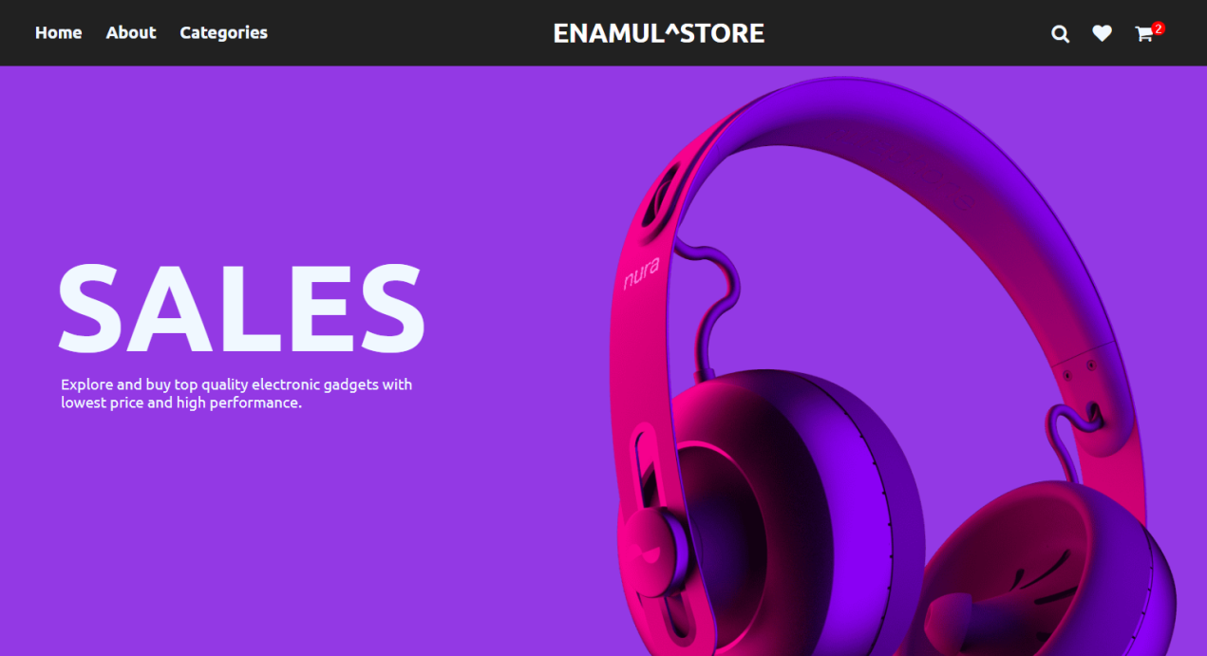

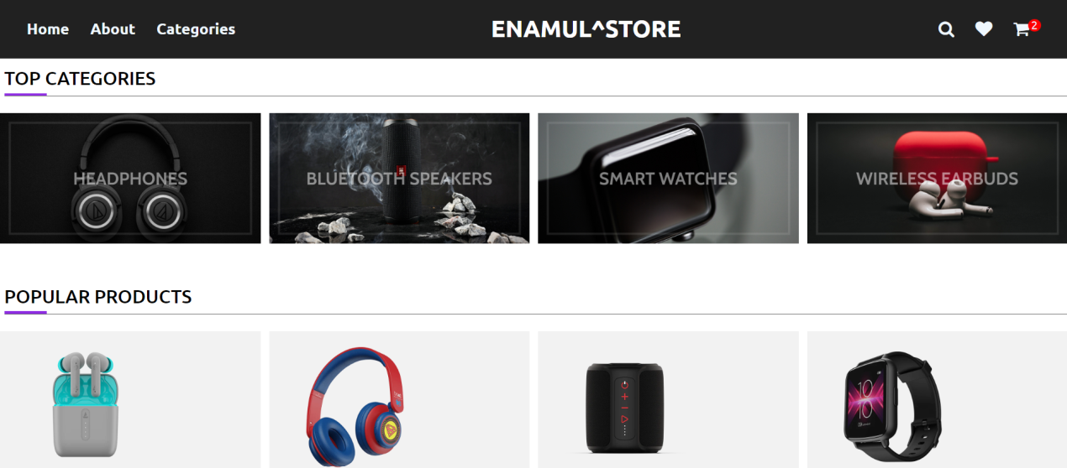

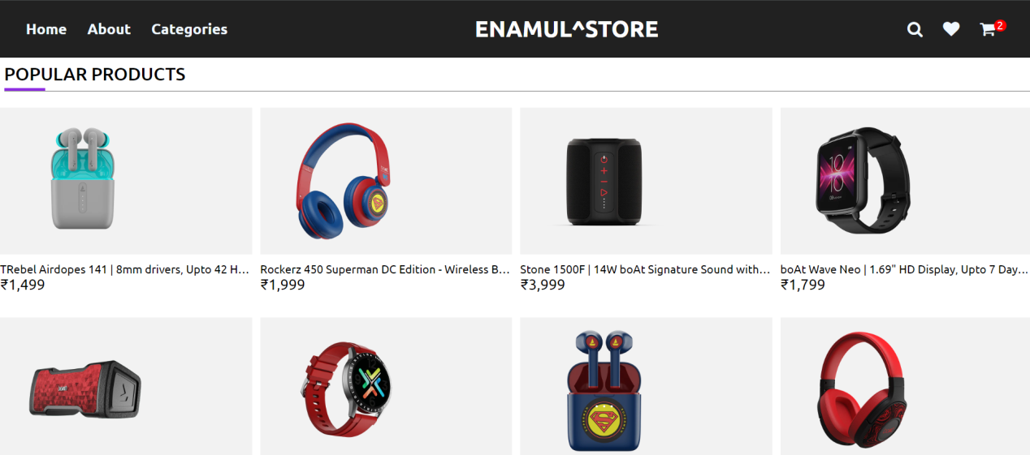

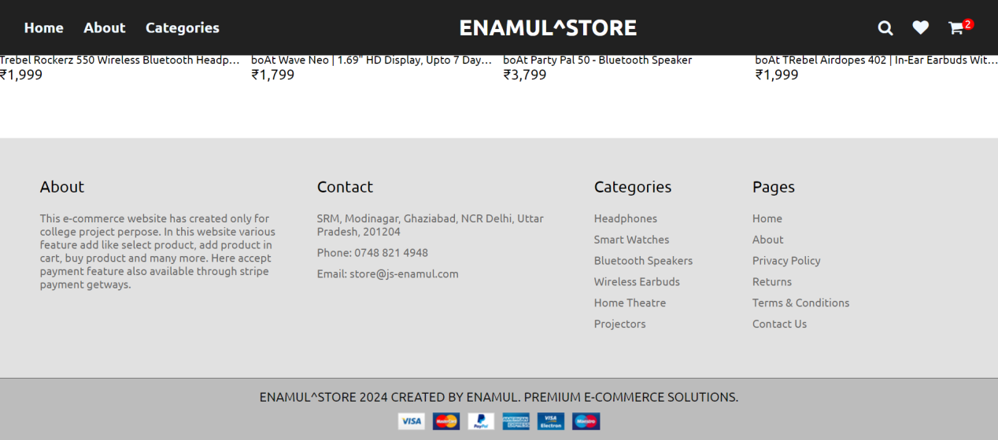

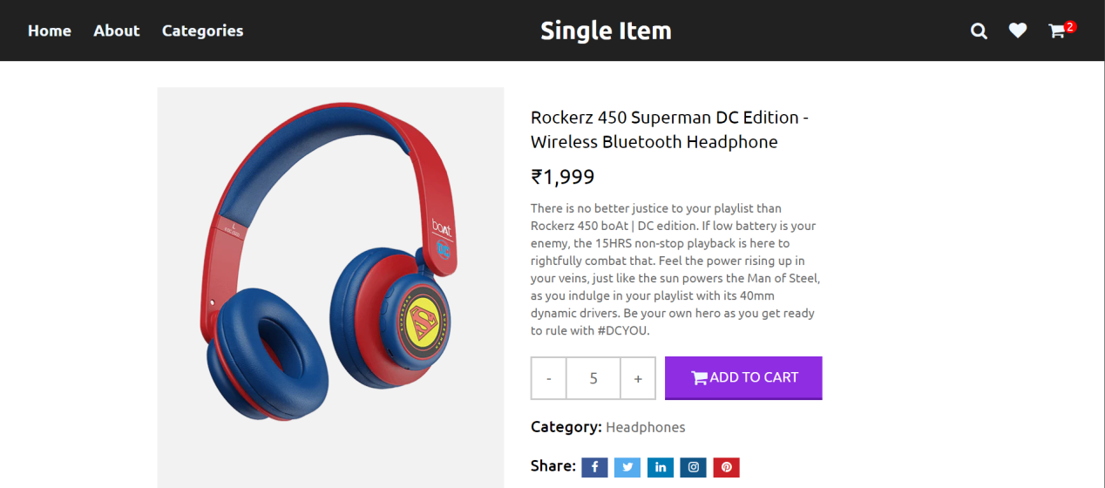

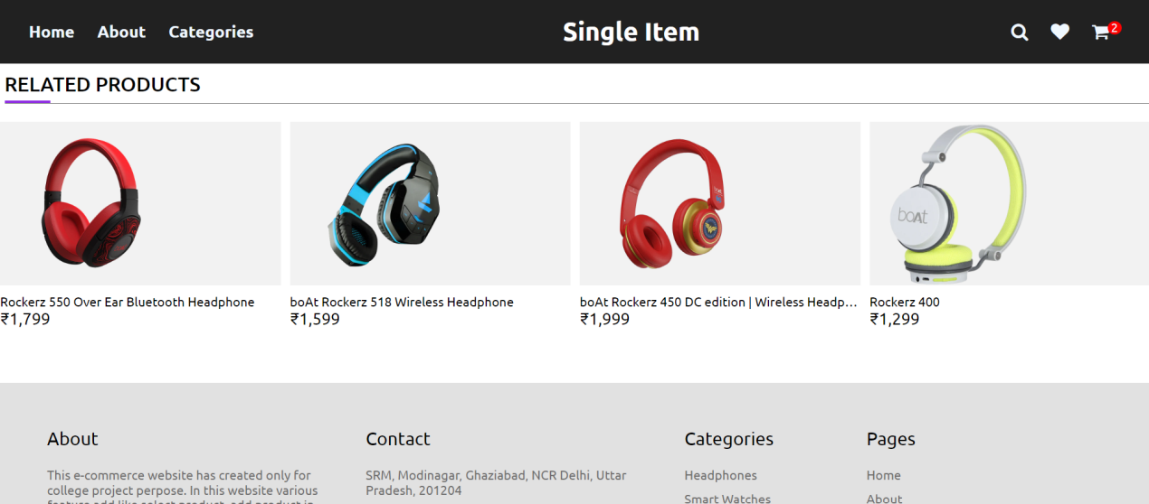

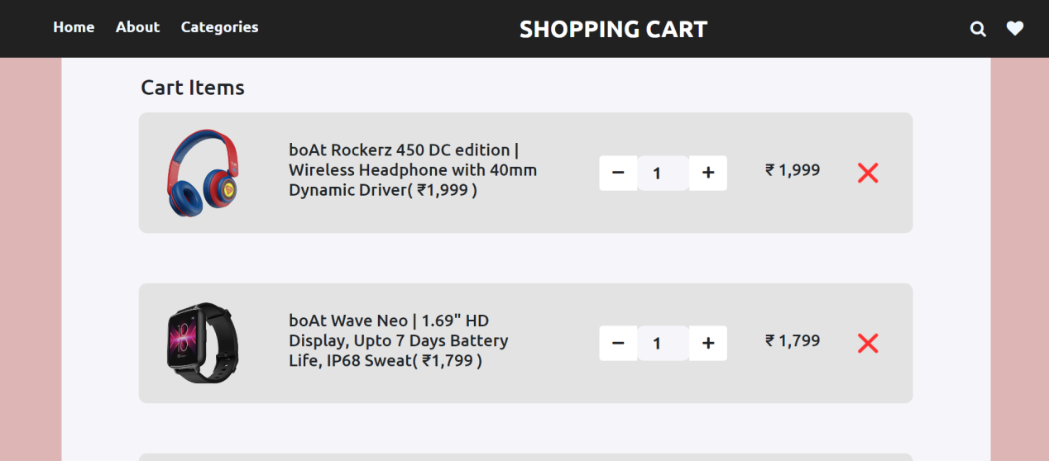

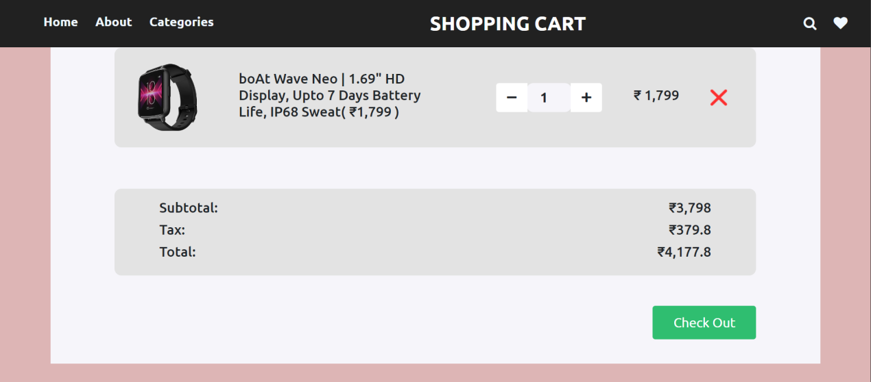

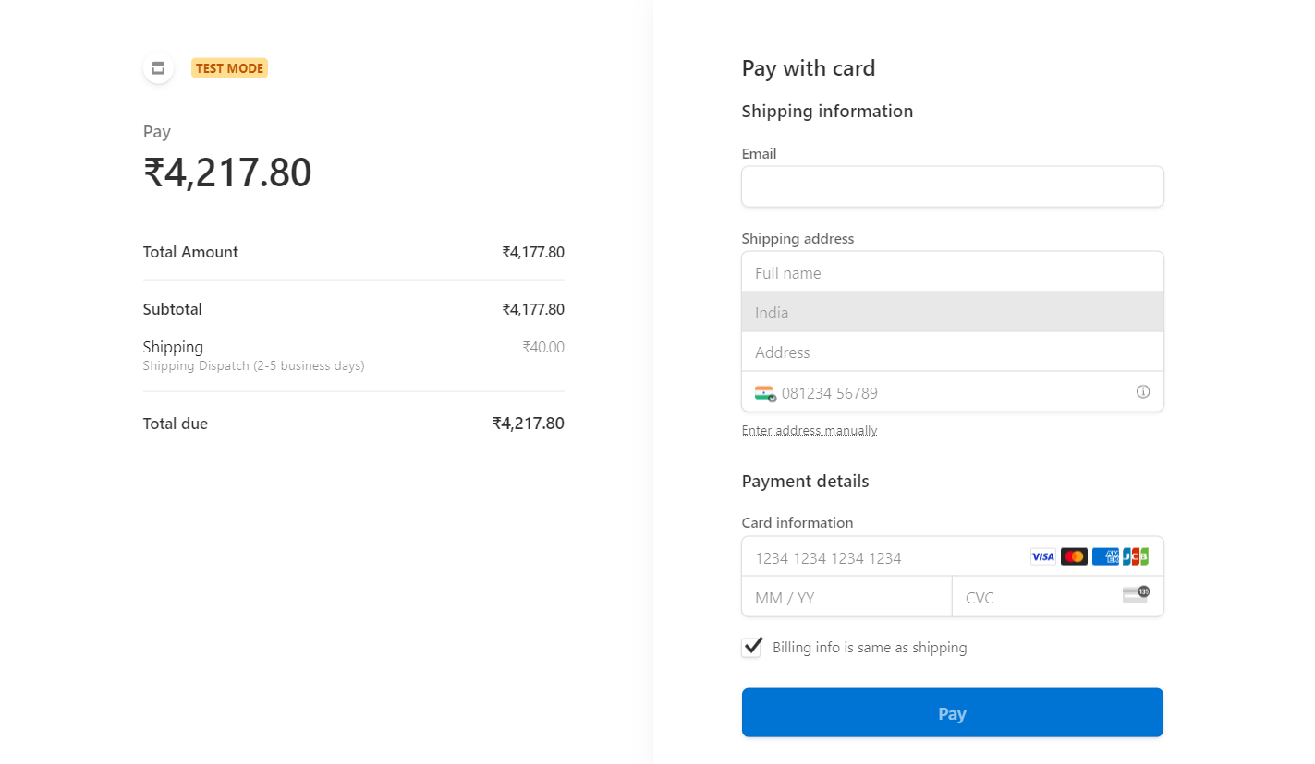

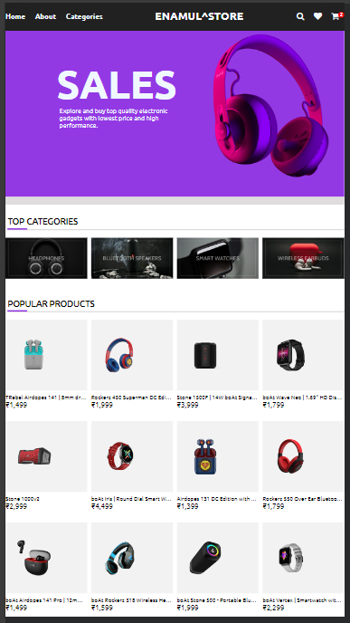

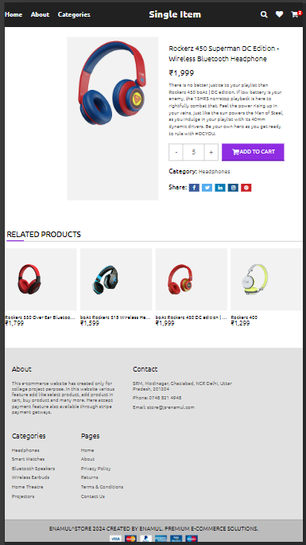

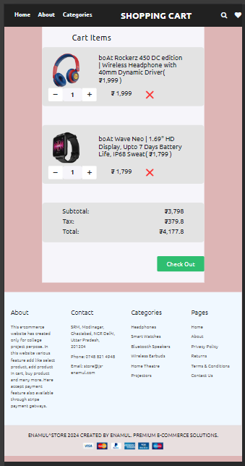

**FUTURE WORK**

The project entitled Online Wearable Product shopping system was completed successfully. The system has been developed with much care and free of errors and at the same time it is efficient and less time consuming. The purpose of this project was to develop a web application and an android application for purchasing items from a shop. This project helped us in gaining valuable information and practical knowledge on several topics like designing web pages using html, css, and javascript usage of responsive templates, designing of android applications, and management of database using stripe. The entire system is secured. Also the project helped us understanding about the development phases of a project and software development life cycle. We learned how to test different features of a project. This project has given us great satisfaction in having designed an application which can be implemented to any nearby shops or branded shops selling various kinds of products by simple modifications. There is a scope for further development in our project to a great extend. A number of features can be added to this system in future like providing admin more control over products so that each moderator can maintain their own products. Another feature we wished to implement was providing classes for customers so that different offers can be given to each class. System may keep track of history of purchases of each customer and provide suggestions based on their history. These features could have implemented unless the time did not limited us.

**REFERENCES**

[1] JavaScript Enlightenment, Cody Lindley-First Edition, based on JavaScript 1.5,ECMA-262, Edition

[2] QuickStart Guide, David DuRocher-First Edition, based on HTML and CSS

[3] Complete CSS Guide ,Maxine Sherrin and John Allsopp-O'Reilly Media; September 2012

[4] Mastering Bootstrap 4, Benjamin Jakobus and Jason Marah – Second Edition: Master the latest version of Bootstrap 4

[5]

<https://www.geeksforgeeks.org/>

<https://www.w3schools.com/>

<https://www.javatpoint.com/>

<https://dashboard.stripe.com/test/dashboard>